**Exponent Rules**

1. The Product Rule



1. The Quotient Rule

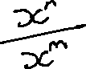

1. The Power Rule



1. Power of Zero



With one exception: 0^0 is undefined.

1. Negative Exponents



1. Fractional Exponents



1. Distribute an Exponent over a Product



1. Distribute an Exponent over a Quotient

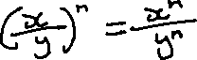

However, you cannot distribute an exponent over add and subtract.

